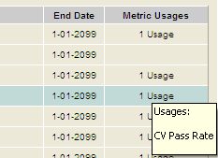

protected void GVMetrics_RowDataBound(object sender, GridViewRowEventArgs e)

{

string usages = "";

if (e.Row.RowType == DataControlRowType.DataRow)

{

object objTemp = GVMetrics.DataKeys[e.Row.RowIndex].Value;

int keys2 = System.Convert.ToInt32(objTemp);

if (Session["Usage"] == null) return;

DataSet ds2 = (DataSet)Session["Usage"];

DataTable dt = ds2.Tables[0];

var query = from o in dt.AsEnumerable()

where o.Field<int>("MetricConfigurationID") == keys2

select o;

usages = "Usages:\n\n";

int conteo = 0;

if (query.Count() > 0)

{

foreach (var emp in query)

{

usages = usages + emp[1] + "\n";

conteo++;

}

e.Row.Cells[10].ToolTip = usages;

if (conteo == 1)

e.Row.Cells[10].Text = conteo.ToString() + " Usage";

else

e.Row.Cells[10].Text = conteo.ToString() + " Usages";

e.Row.Cells[10].Font.Underline = true;

e.Row.Cells[10].ForeColor = System.Drawing.Color.Blue;

}

else

e.Row.Cells[10].Text = "";

}

}